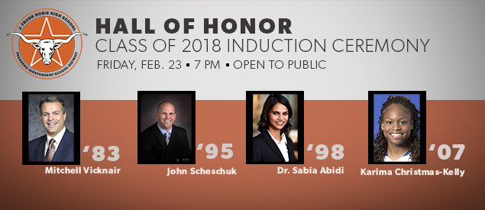

By Reesha Brown
PISD Alumni/Communication Coordinator
Four graduates from Dobie High School will make history as they are inducted into the Longhorn Hall of Honor during a banquet ceremony on February 23, starting at 7 p.m.
The inductees are: Mitchell Vicknair, Class of 1983; John Scheschuk, Class of 1995; Dr. Sabia Taqvi Abidi, Class of 1998; and Karima Christmas-Kelly, Class of 2007.
The Hall of Honor Class of 2018 will bring the total number of alumni, former faculty members and community volunteers that have been inducted to 44 since it was unveiled in 2013.
Vicknair spent the majority of his career in banking and financial services before assuming his current role as president and CEO of American Finasco, a national debt management company that helps financially distressed small businesses avoid bankruptcy and foreclosures. Vicknair’s passion for small business administration lending encouraged him to team up with a business partner and launch Private Mortgage Financing Partners, LLC. a few years after joining American Finasco. Aside from his business ventures, Vicknair maintains an active role in the community. He served as a Catholic missionary for the National Evangelization team and chaired several charity events for his church. Vicknair currently serves on the core team for a prison ministry, where he regularly visits inmates to provide spiritual support and teach life skills.
Scheschuk ranks as one of the most successful student-athletes in the annals of both Dobie and Texas A&M. Arguably, the Longhorns’ most honored baseball player, Scheschuk is still remembered as perhaps the most selfless and team-oriented player ever to wear an Aggies uniform. At Dobie, he was lauded for both his hitting and pitching. The Longhorns’ starting quarterback for two seasons, Scheschuk started three years for the Longhorns’ baseball team and was chosen twice as district MVP, All-Greater Houston and first-team all-state. Dobie qualified for the playoffs in each of his three seasons – and to cap Scheschuk’s high school career, the Longhorns advanced to the regional finals. As an Aggie, he earned four letters as a hard-hitting A&M first baseman, twice was named second-team All-Big 12 and in 1999 captained the Aggies to a berth in the College World Series. Two years ago, he was inducted into the Pasadena ISD Athletics Hall of Fame. The year before that, he was inducted into the A&M Athletics Hall of Fame.
Dr. Abidi is a former science coordinator at New York University’s medical school who currently serves as a postdoctoral associate at the Massachusetts Institute of Technology (MIT). She earned a bachelor of science in biomedical engineering from Texas A&M in 2002, graduating cum laude, and five years later earned her doctorate in the same field from the University of Texas-Austin. From 2000 to 2007, she held four graduate assistant and intern positions, including one with the Neurosciences Department at NASA. After interning at NYU in 2006, she joined the medical school’s Department of Microbiology as the science coordinator with duties that included grant-writing, strategy analysis and communications. After three years, Dr. Abidi accepted a fellowship in NYU’s Department of Medical Parasitology. The focus of her studies was the treatment of malaria. Her current postgraduate work is for MIT’s Department of Material Science and Engineering.
Last fall, Christmas-Kelly completed her seventh season in the WNBA and her second as a starting forward and double-digit scorer for the Dallas Wings. She shot to national fame in college as a scoring dynamo for the Blue Devils of Duke University. Over her junior and senior seasons at Duke, she led her team to back-to-back regular-season and Atlantic Coast Conference tournament titles. She became the 27th player in Duke women’s history to break the 1,000 mark for career points. At Dobie, Christmas earned 10 varsity letters, including four in track, where she won a district title in the triple jump. In basketball, she was a three-time all-district selection and an all-region pick her senior year when Parade Magazine named her a fourth-team All-American. She averaged 18.7 points and 9.6 rebounds her senior season, leading her team to a 32-7 record. Christmas-Kelly returned to the South Belt area last fall to provide Hurricane Harvey refugees with shoes and sports gear. Her Dobie basketball jersey was retired by the school last year during the McDonald’s Texas Invitational Basketball Tournament.

